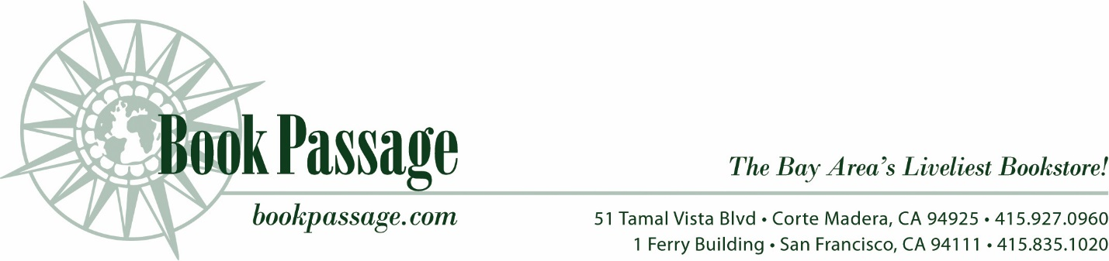

Date:
Re: Consignment Agreement

Dear Author,

Book Passage, Inc. is pleased to carry your books on consignment. It is our hope that we can work with you to make your books available to interested readers in our store.
This letter will confirm the terms of consignment for the book or books listed in Exhibit A attached to this letter. Unless otherwise agreed by both parties, the terms of this letter will apply to any future books that Book Passage, Inc. agrees to carry. If this is agreeable, please sign a copy of this letter and return it to us.

- Ownership and Quantity
As consignor, you will retain ownership of the books until they are sold to customers. You will be asked to work with the Book Passage Consignment Manager to determine the agreed number of copies to consign to us at any given time and pick up the any books remaining at the end of the consignment at your expense. Book Passage, Inc. will endeavour to protect your books that are consigned to the store to the same extent it protects other merchandise in the store, but it is not responsible for any theft of the books or other unexplained loss or damage.
- Term of Agreement
Book Passage ordinarily holds the agree number of copies of your book for up to 90 days unless it determines that a shorter period is warranted. If you wish to remove some or all of the copies of the book from the store at any time, you are free to do so upon prior arrangement with the Book Passage Consignment Manager. At the end of the consignment period you will be asked to remove all unsold copies. Depending on sales, we may wish to keep some copies beyond the normal consignment period if that is agreeable to you.
- Sale of Books
Book Passage, Inc. is authorized to sell any copies of your books that are in the store at the time of sale. You also agree to provide us with any additional copies that might be necessary to complete any customer purchase made by telephone, mail order, or internet if there are insufficient copies of the book in the store to complete the transaction.
- Sale Price and Payment
You will set the retail sales price of your books. If you make any change that will require a change of any pre-printed price on the books, you will work with the Consignment Manager to make those changes. Books will be sold at the retail price that you set except in situations where Book Passage offers discounts or sale prices for books in the normal course of its business. You will receive 50% of the retail price that is received by Book Passage, and the remaining 50% will be retained by Book Passage as its fee for providing this consignment service. Any money due to you from sales will ordinarily be paid to you by check within 30 days of the end of that month if the amount due at that point is $25.00 or more on cumulative sales. If there is any amount still due to you at the end of the calendar year, it will be paid to you by January 31 of the following year.
- Sales Promotion
You are strongly urged to encourage the sale of your books to your friends and acquaintances and through your own website, social media, and other promotional methods. If you include in your promotional material any arrangements for purchase of your books, you agree that Book Passage will be prominently included in such listings. If your internet or social media promotions contain any buy-links for purchase of your books, you agree that an appropriate and equal buy-link to bookpassage.com will be included.
- Independent Contractors
Your arrangement with Book Passage is that of an independent contractor for consignment of merchandise. No partnership, joint venture, agency, or similar arrangement is contemplated under this agreement. The terms and conditions set forth herein constitute the entire agreement between the parties.

We look forward to working with you to sell your books.

Sincerely,
Valentina Castro
Consignment Manager

These terms are agreed to:

NAME TEL.

PAYMENT ADDRESS

CITY/STATE ZIP CODE

EMAIL

Exhibit A:
Title

ISBN Price

Author Genre

Number of books Publication Date

Please use this format for any additional books, if applicable, that are brought to Book Passage.

